Experiment No. 2

Title:
Student Database Management System using C

Aim:
To design and implement a C program that efficiently manages student data, including adding, displaying, searching, and sorting student records based on their average marks.

Objectives:
- To understand the use of structures in C for managing related data.
- To implement functions for modular programming.
- To create a system capable of storing multiple student records.
- To perform operations such as adding, displaying, searching, and sorting student data.
- To enhance understanding of arrays, loops, and decision-making statements in C.

Requirements:

Hardware Requirements:
- Processor: Intel i3 or higher
- RAM: Minimum 2 GB
- Storage: Minimum 100 MB free space

Software Requirements:
- Operating System: Windows / Linux
- Compiler: GCC / Turbo C / Code::Blocks / Dev-C++

Description:
This program is a simple Student Database Management System that allows users to store and manage student records.
Each record consists of a student's roll number, name, and marks in three subjects.
The system supports the following operations:
- Add Student: Accepts student details and calculates the total and average marks.
- Display All Students: Displays a formatted list of all student records.
- Search Student: Finds and displays student details based on roll number.
- Sort Students: Sorts all student records in descending order of average marks using the bubble sort algorithm.
- Exit: Terminates the program safely.
The data is stored in an array of structures, ensuring efficient organization and easy access of student information.

Algorithm:

Step 1: Start the program.

Step 2: Define a structure Student with fields:
- rollNo (integer)
- name (string)
- marks[3] (integer array)
- total (integer)
- average (float)

Step 3: Create an array students[MAX] to store records and a variable count to track the number of students.

Step 4: Display a menu with options:
- Add Student
- Display All Students
- Search by Roll Number
- Sort by Average Marks
- Exit

Step 5: Based on the user’s choice, perform the following:
- Add Student:
  - Accept roll number, name, and marks.
  - Calculate total and average.
  - Store the record in the array.
- Display Students:
  - Display roll number, name, total, and average for each student.
- Search Student:
  - Accept roll number input.
  - Search the array for the student and display details if found.
- Sort Students:
  - Use Bubble Sort to arrange students in descending order of average marks.

Step 6: Repeat the menu until the user chooses to exit.

Step 7: Stop the program.

Conclusion:
The Student Database Management System successfully demonstrates how structures and functions in C can be used to store and manipulate student information.
The program efficiently performs data handling tasks like adding, searching, displaying, and sorting records.
This project provides a strong foundation for understanding data organization, structured programming, and basic database concepts using the C language.

C Program to Implement Student Database Management.
#include <stdio.h>
#include <string.h>

#define MAX 100 // Maximum number of students
#define SUBJECTS 3 // Total number of subjects per student

// Define a structure to store student details
struct Student {
int rollNo; // Roll number of the student
char name[50]; // Name of the student
int marks[SUBJECTS]; // Marks in 3 subjects
int total; // Total marks of all subjects
float average; // Average marks
};

// Global array to store all students and variable to count them
struct Student students[MAX];
int count = 0;

// Function to add a new student record
void addStudent() {
if (count >= MAX) {
printf("No space to add more students.\n");
return;
}

struct Student s; // Temporary variable to store new student data

// Input student roll number
printf("\nEnter Roll No: ");
scanf("%d", &s.rollNo);

// Input student name
printf("Enter Name: ");
scanf(" %[^\n]", s.name); // %[^\n] allows reading full name with spaces

// Input marks for each subject
s.total = 0;
printf("Enter marks for %d subjects:\n", SUBJECTS);
int i;
for (i = 0; i < SUBJECTS; i++) {
printf("Subject %d: ", i + 1);
scanf("%d", &s.marks[i]);
s.total += s.marks[i]; // Add marks to total
}

// Calculate average marks
s.average = s.total / (float)SUBJECTS;

// Add the student record to the global array
students[count++] = s;

printf("Student added successfully!\n");
}

// Function to display all student records
void displayStudents() {
if (count == 0) {
printf("No students to display.\n");
return;
}

// Print table header
printf("\n%-5s %-20s %-10s %-10s\n", "Roll", "Name", "Total", "Average");

int i;
// Loop through all students and display their details
for (i = 0; i < count; i++) {
printf("%-5d %-20s %-10d %-10.2f\n",
students[i].rollNo,
students[i].name,
students[i].total,
students[i].average);
}
}

// Function to search for a student by roll number
void searchStudent() {
int roll;
printf("Enter Roll No to search: ");
scanf("%d", &roll);

int i;
// Loop through all student records to find a match
for (i = 0; i < count; i++) {
if (students[i].rollNo == roll) {
printf("\nStudent Found:\n");
printf("Name: %s\n", students[i].name);
printf("Total: %d\n", students[i].total);
printf("Average: %.2f\n", students[i].average);

// Print marks in each subject
printf("Marks: ");
int j;
for (j = 0; j < SUBJECTS; j++) {
printf("%d ", students[i].marks[j]);
}
printf("\n");
return; // Exit the function after finding the student
}
}

// If no match found
printf("Student with Roll No %d not found.\n", roll);
}

// Function to sort students by their average marks in descending order
void sortStudents() {
if (count < 2) {
printf("Not enough students to sort.\n");
return;
}

int i, j;
// Using Bubble Sort algorithm to sort by average marks
for (i = 0; i < count - 1; i++) {
for (j = 0; j < count - i - 1; j++) {
if (students[j].average < students[j + 1].average) {
// Swap records if not in correct order
struct Student temp = students[j];
students[j] = students[j + 1];
students[j + 1] = temp;
}
}
}

printf("Students sorted by average marks.\n");
}

// Main function: Menu-driven program
int main() {
int choice;

do {
// Display the main menu
printf("\n--- Student Management System ---\n");
printf("1. Add Student\n");
printf("2. Display All Students\n");
printf("3. Search by Roll Number\n");
printf("4. Sort by Average Marks\n");
printf("5. Exit\n");
printf("Enter your choice: ");
scanf("%d", &choice);

// Perform operation based on user choice
switch (choice) {
case 1:
addStudent();
break;
case 2:
displayStudents();
break;
case 3:
searchStudent();
break;
case 4:
sortStudents();
break;
case 5:
printf("Exiting...\n");
break;
default:
printf("Invalid choice. Try again.\n");
}

} while (choice != 5); // Repeat menu until user chooses to exit

return 0;
}

Output:
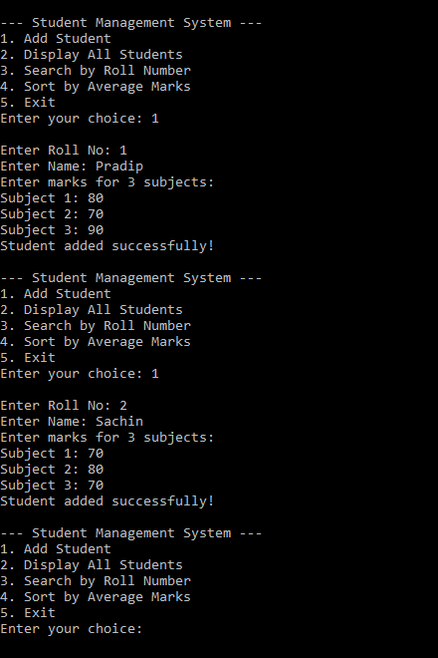
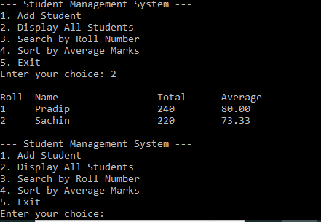

Viva Questions:
- What is searching? Name two searching techniques.
- What is Linear Search? Explain its working.
- What is the time complexity of Linear Search in the best and worst cases?
- Does Linear Search require a sorted array?
- What is Binary Search? Explain its working.
- Why must the array be sorted before applying Binary Search?
- What are the roles of low, high, and mid in Binary Search?
- What is the time complexity of Binary Search in the best and worst cases?
- What is the difference between Linear Search and Binary Search?
- Which searching technique is more efficient for a large sorted array, and why?

Real-Life Need of the Experiment

1. Efficient Record Management
Instead of maintaining paper registers or spreadsheets, student information can be stored digitally.
Example:
- Student Name
- Roll Number
- PRN Number
- Branch
- Semester
- Contact Number
- Email ID
- Marks
Benefit: Faster access and organized storage.

2. Quick Searching of Student Records
Finding a student's information manually may take several minutes.
Using a C program, records can be searched instantly using:
- Roll Number
- Name
- PRN Number
Real-life Example:
During admission or examination, administrators can retrieve a student's details within seconds.

Real-Life Applications
- College Student Information System
- School Administration Software
- Examination Cell Management
- Attendance Management System
- Hostel Management System
- Placement Cell Database
- Scholarship Record Management
- Alumni Database
- Online Admission Systems
- University ERP Systems
Variation In experiment:
Student Need to Add Grading system considering Distinction, First class, Second Class, Pass, Fail.

